

Unilever – Home Care Heroes

Functional Specification

# Confidential Information

This document is submitted under strict commercial confidentiality and no part of it may be disclosed for any reason to any third party without prior written consent from authorised representatives of Golin.

# Document History

|  |  |  |
| --- | --- | --- |
| Date | Author | Comments |
| 17/5/17 | Peter Kemp |  |

# Reviewers

|  |  |  |
| --- | --- | --- |
| Date | Name | Position |
| 17/5/17 | Rosalind Harber | Digital Project Manager |

Table of Contents

Confidential Information 2

Document History 2

Reviewers 2

1 Overview 5

2 Business requirements 5

3 UX & User Interface Design 5

4 Pages 6

4.1 Home 6

4.2 Previous Winners 11

5 Every Day Hero Approval & Notification Email 13

6 Information Architecture 15

6.1 Site collection 16

6.2 Lists 16

6.3 Libraries 17

6.4 Content Types 17

6.5 Site Columns 18

7 Permissions 20

8 Solution Assets 20

8.1 Master pages 21

8.2 Page layouts 21

8.3 CSS 22

8.4 JavaScript 22

8.5 Frameworks and Libraries 22

8.6 Imagery 23

8.6.1 Image renditions 23

8.7 Fonts 23

9 Accessibility 24

10 Development 24

10.1 Code Control 24

11 Browser & Device Testing 24

12 Deployment 25

13 Training & Handover 26

14 Documentation 26

15 Appendix 26

15.1 The Every Day Heroes GIF Creator 26

# Overview

The following document provides detailed functional and technical specifications for the development of the Home Care Heroes site. The site will be built on SharePoint on Unilever’s Inside.Unilever Microsoft Office 365 tenancy.

The specifications and information in this document are limited to the technical implementation of the Home Care Heroes site and assume administrative knowledge of SharePoint Online and Office 365.

# Business requirements

The Home Care Heroes site will be a platform where employees can receive and give recognition for the great work that they do. There are two main areas of the site:

* **Our Winners** - A place where the Global Corporate Leadership (GCL) Team can recognise and give thanks to selected employees.
* **Every Day Heroes** – A place where every Home Care employee can recognise the great work of a fellow employee.

A version of the site already exists; however, it has not gained the user traction that the team would like. Therefore, the site needs to be recreated and be visually engaging, intuitive, fun and inspire its visitors.

# UX & User Interface Design

The UX and User interface designs for each page of the site have been defined and created by Unilever’s U Studio team. The UI designs have been provided to Golin in the form of PSD files.

# Pages

The following section outlines the main pages/views created as part of the Home Care Heroes site and the features and functionality of each.

## Home

The Home page is the primary entry point for most users of the Home Care Heroes site and provides quick access to the key areas of the site.

The page, which is set as the home page of the site collection, will be created from a single publishing page and use a series of Content Editor Web Parts to render HTML templates that drive the page content.

The following annotated image shows the design for this page:

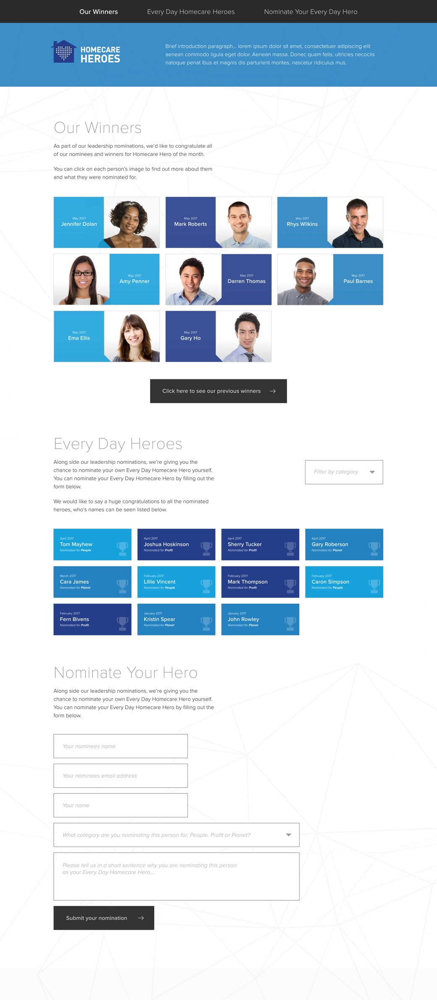

The numbered components are outlined below:

1. **Navigation.** This area provides quick access to each section of the Home page. Clicking on a heading automatically scrolls the page to the relevant area of the page and highlights the header. The headers will be driven from the HCH Sections list, where the user can define the title and order of the items.
2. **Logo.** An area that displays the logo for the Home Care Heroes site using the out-of-the-box SharePoint SiteLogoImage control. Clicking on the logo redirects the user to the home page of the site.
3. **Strapline.** An area that displays a description of the Home Care Heroes site. This is driven from the Strapline site column from the page Content Type.
4. **Our Winners Title and Description.** An area that displays the title and description for the Our Winners section of the page. The text for the title and description will be driven from the HCH Sections list.
5. **Our Winners.** The section will show a listing of the current month’s winners, each item will include the person’s name, their brand, their photo and the month that they are being nominated in. The Winners photos will be uploaded directly into the Home Care Heroes site by the administrator and will not be automatically pulled from the User Profile Service or Active Directory. Unlike the Every Day Heroes section, the background colours for the tiles will be fixed and match the designs provided. Clicking on a tile will show a popup that contains more information about the winner including descriptive text.

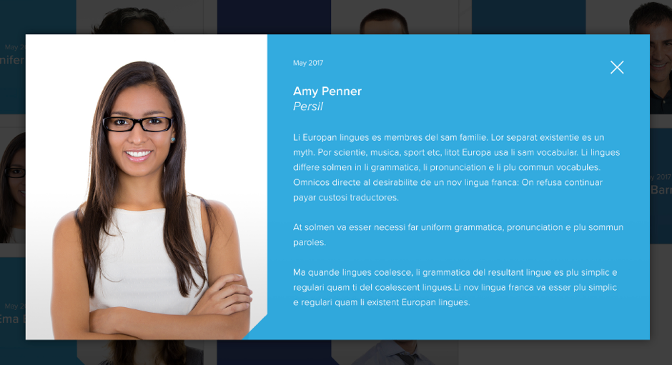

This information will be managed by permissioned administrators from the Our Winners list. Each item will have an Expiry Date which will define when the item should be displayed in the Our Winners section or the Previous Winners section.

1. **Previous Winners.** A button that directs the user to the Previous Winners page. The details of the Previous Winners page are outlined in the following section.
2. **Every Day Heroes Title and Description.** An area that displays the title and description for the Every Day Heroes section of the page. The text for the title and description will be driven from the HCH Sections list.
3. **Every Day Heroes Filter.** A drop down that allows the user to filter the Every Day Heroes listing by a selection of filters. The user can only filter the listing by one Category at a time. The Categories are held in the HCH Every Day Heroes Categories list, which is associated with the HCH Every Day Heroes list via a lookup column.
4. **Every Day Heroes.** This section will show a listing of people that have been nominated by visitors to the site in the most recently Created order. Unlike the Our Winners section, the items are not clickable, but would show the person’s name, the month they were nominated and which category they were nominated for. There would be a shade of blue for each of the nomination categories, which can be defined by the administrator as a hex code in the Every Day Heroes list. The area will show a maximum of 30 most recent items with a button to show subsequent items.

Nominations are held in the HCH Every Day Heroes list, where out-of-the-box SharePoint alerts will be configured to notify the administration team that a new item is created. The administration team will then be able to approve the item before it is presented in the Every Day Heroes section. If the item is approved, an email is then sent to the inputted email address. The email functionality is outlined in more detail in the section on Every Day Heroes Approval & Email Notifications.

1. **Nominate Your Hero.** This is a web form that enables the user to input their nomination details, which will populate the HCH Every Day Heroes list with a new item. An annotated version of the form is shown below:

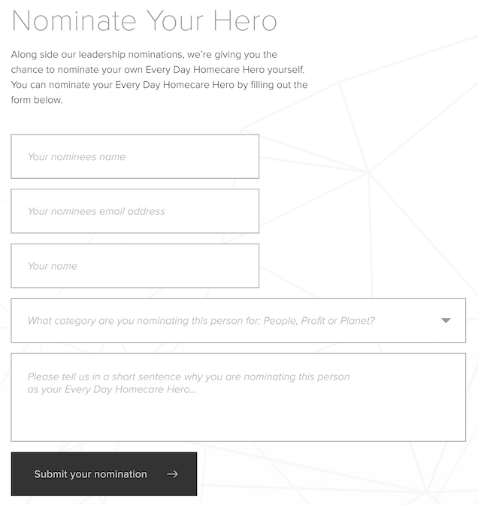

* 1. **Nominate Your Hero** **Title and Description.** An area that displays the title and description for the Nominate Your Hero form. The text for the title and description will be driven from the HCH Sections list.
  2. **Every Day Heroes** **Name.** A Single Line of Text field that enables the user to input the Nominees name. This is not pulled from Active Directory and is inputted as free text into the Every Day Heroes list. This field is used in the content of the notification email.
  3. **Every Day Heroes** **Email.** A Single Line of Text field that enables the user to input the Nominees email address. This is not pulled from Active Directory and is inputted as free text into the Every Day Heroes list. This field is used as the email address for the notification email.
  4. **Your name.** This information can be pulled from Active Directory and the User Profile Service and can be removed from the form.
  5. **Every Day Heroes** **Category.** A drop down that enables the user to choose a single category for the nominee. The options are driven from the HCH Every Day Heroes Categories list.
  6. **Every Day Heroes** **Description.** A Single Line of Text field that enables the user to input a reason for their nomination. This information is inputted into the HCH Every Day Heroes list and is not presented on the page or in the notification email.
  7. **Submit your nomination.** Once the user clicks the Submit your nomination button the item is created in the Every Day Heroes list. The user is then presented with the following message:

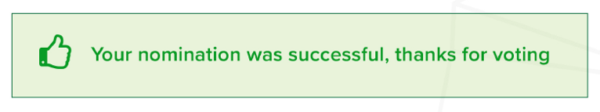

If the user refreshes the page, the original form is them presented again.

## Previous Winners

The Directory page is where the user can browse the complete list of the available profiles.

The page will be created from a single publishing page and use a series of Content Editor Web Parts to render HTML templates that drive the page content.

The following annotated image shows the design for this page:

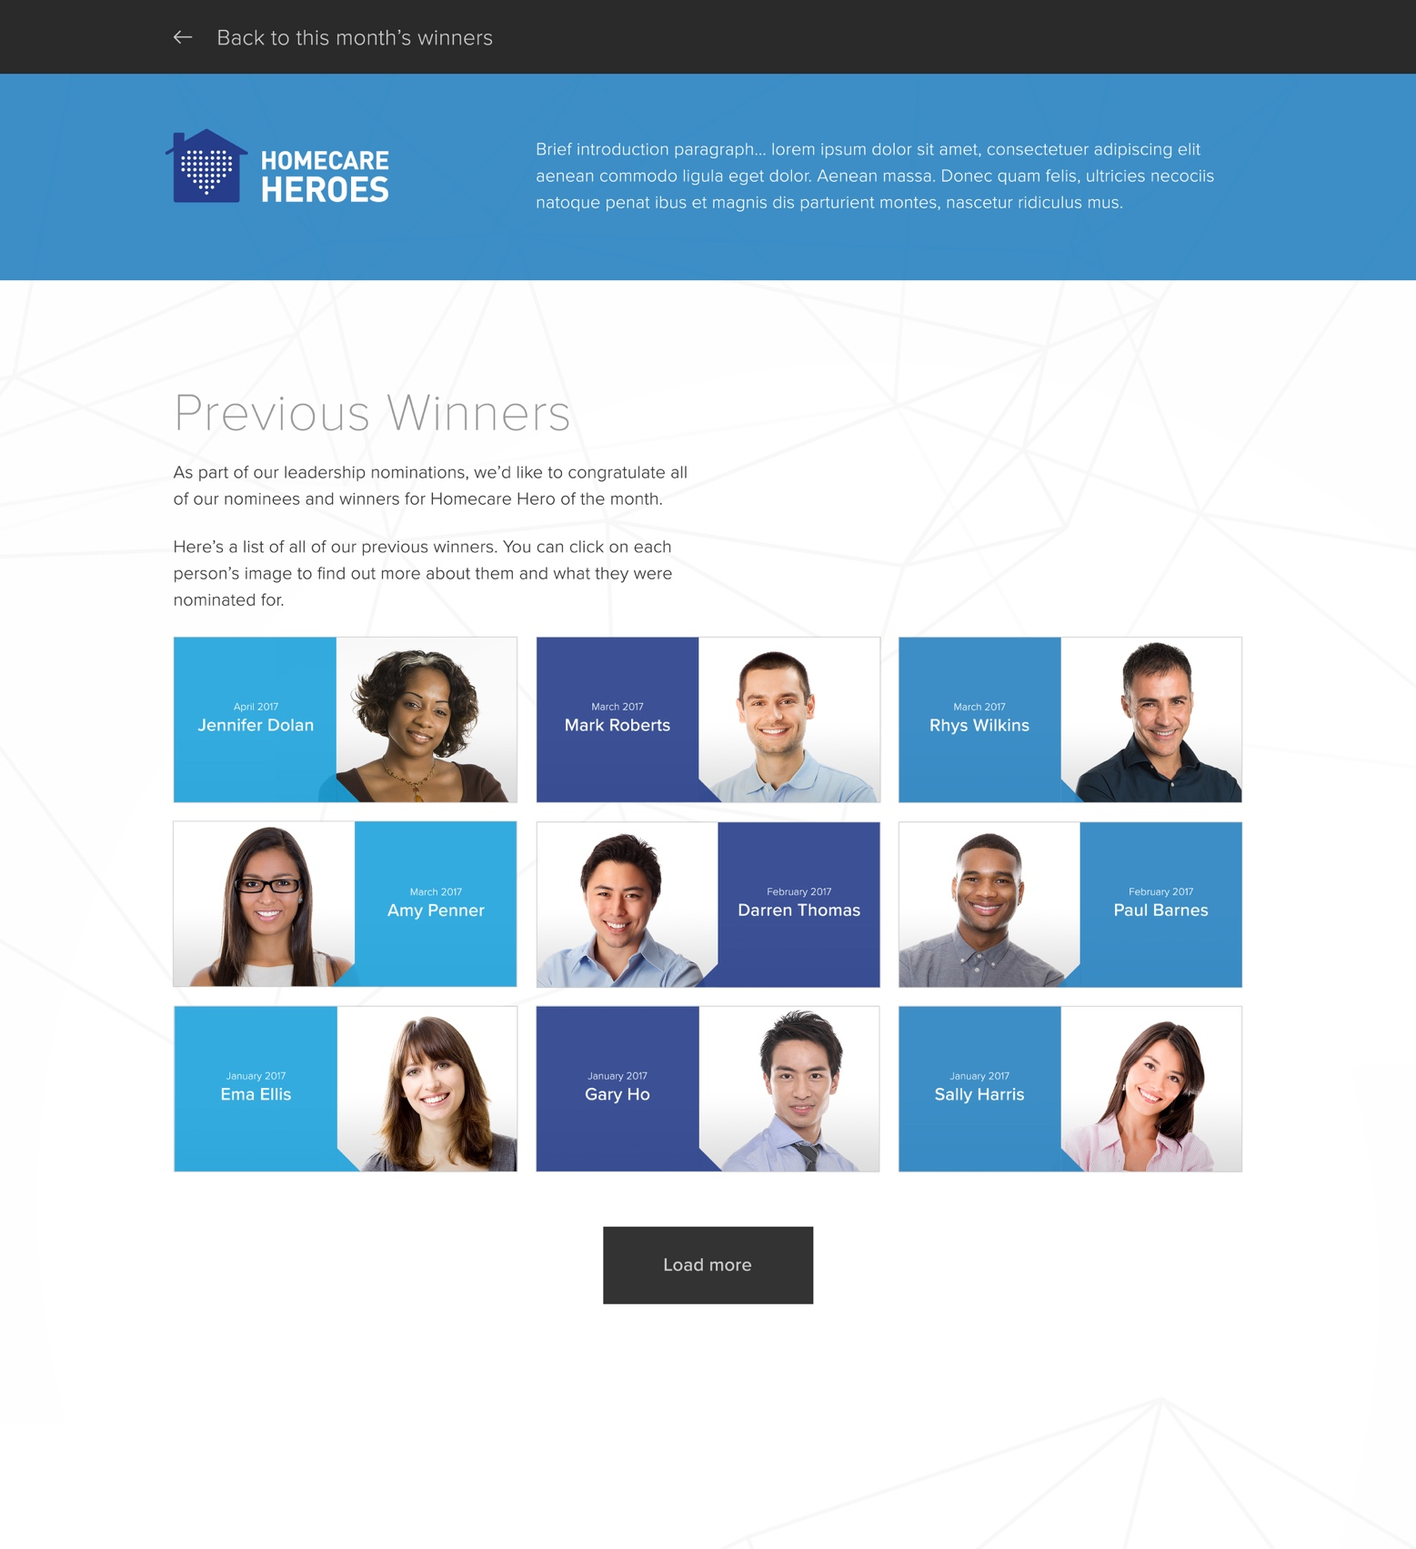

The numbered components are outlined below:

1. **Navigation.** This area provides quick access to each section of the Home page. Clicking on a heading automatically scrolls the page to the relevant area of the page and highlights the header. The headers will be driven from the HCH Sections list, where the user can define the title and order of the items.
2. **Logo.** An area that displays the logo for the Home Care Heroes site using the out-of-the-box SharePoint SiteLogoImage control. Clicking on the logo redirects the user to the home page of the site.
3. **Strapline.** An area that displays a description of the Home Care Heroes site. This is driven from the Strapline site column from the page Content Type.
4. **Previous Winners Title and Description.** An area that displays the title and descriptions for the Previous Winners section of the page. The text for the title and description will be driven from the HCH Sections list.
5. **Previous Winners.** The section will show a listing of the previous winners, each item will include the person’s name, their brand, their photo and the month that they are being nominated in. Unlike the Every Day Heroes section, the background colours for the tiles will be fixed and match the designs provided. Clicking on a tile will show a popup that contains more information about the winner including descriptive text.



This information will be managed by permissioned administrators from the Our Winners list. Each item will have an Expiry Date which will define when the item should be displayed in the Our Winners section or the Previous Winners section.

Ordered by the Nominated date, the list will initially show nine items with a button at the bottom of the page to show subsequent items.

# Every Day Hero Approval & Notification Email

When the user successfully completes the Nominate Your Hero form the information is created as an item in the Every Day Heroes list. In the list, Approval is set to ‘Required’ therefore the item’s status will automatically be set as ‘Pending’ and will not display on the site’s Home page.

An out-of-the-box SharePoint Alert notification will be configured on the Every Day Heroes list to notify the members of the Home Care Heroes Owners group that a new item has been created and is ready for Approval.

If the item is left as Pending or set as Rejected then the item will not be displayed on the site’s Home page. If the item is set as Approved; the item will then be displayed on the Home page and an email will be sent to the Nominee.

**NOTE** No functionality will be included to notify the Nominator that their nomination has been approved or rejected.

The email will be sent via a SharePoint Designer workflow that is triggered as soon as an item is approved. The recipient for the email will be set by the email address provided via the form and held in the list item.

**NOTE** It may be possible to migrate this feature to Microsoft Flow in the future, but at the time of writing this document the workflow triggers do not include approvals.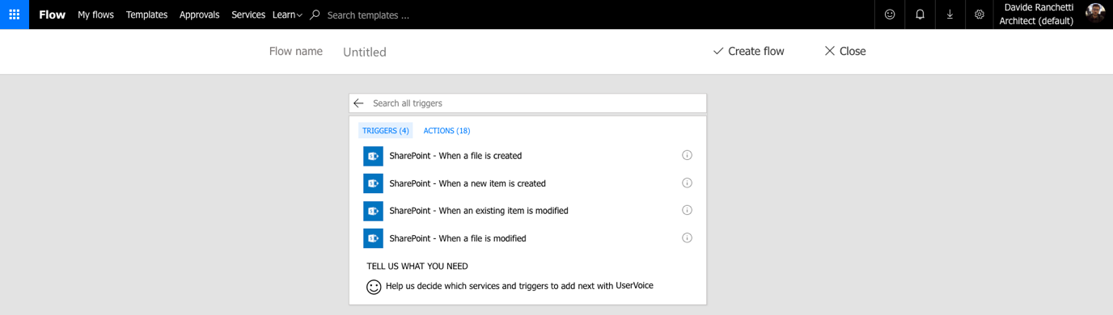

The following annotated image shows the design for the email template:

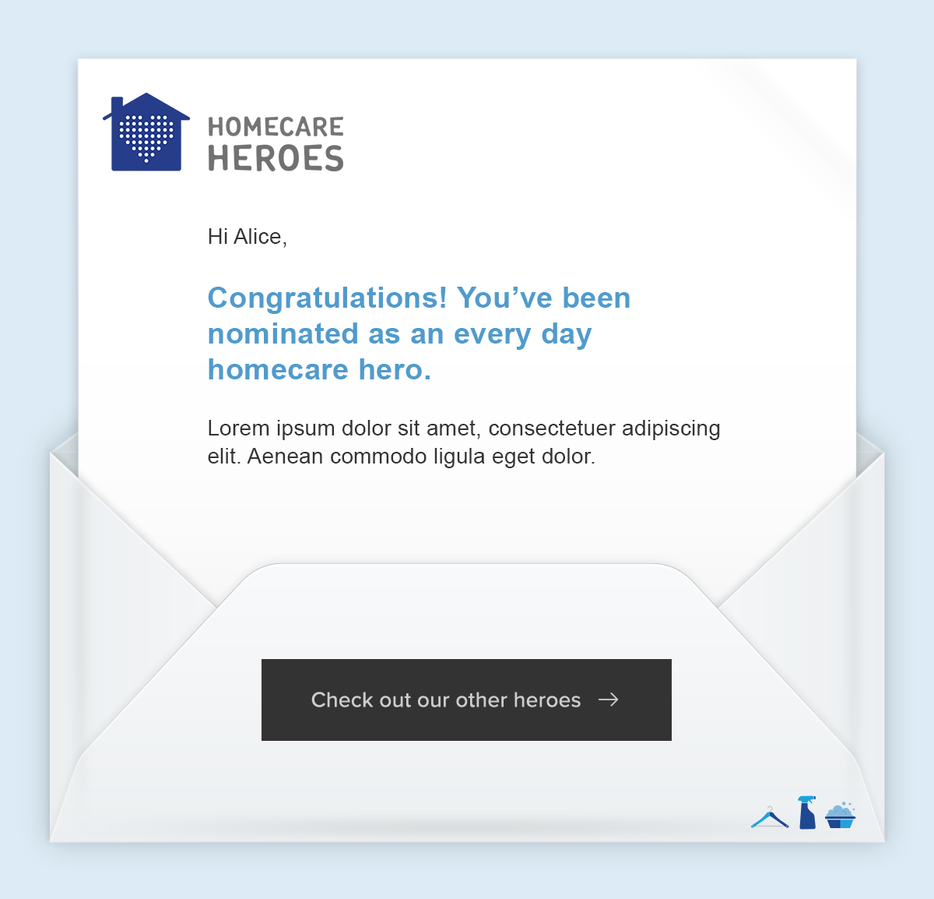

The numbered components are outlined below:

1. **Background Image.** This image will be hard coded in the content of the email and will only be changeable via the SharePoint Workflow.
2. **Nominee Name.** Pulled from the Title field in the HCH Every Day Heroes list.
3. **Body Text.** This will be pulled from an item in the HCH Config list.
4. **Hyperlink.** This will be pulled from an item in the HCH Config list.

# Information Architecture

The following section provides detailed information on the information architecture for the site. This includes the following topics:

* Overall site structure
* Detail on the lists and libraries used as part of the solution
* Listings of required content types and site columns

## Site collection

The Home Care Heroes site will be built entirely on the top-level site of a single site collection. The lists and libraries outlined in the following sections will all be held in the top-level site.

## Lists

The following section outlines the main lists that sit within this site.

|  |  |
| --- | --- |
| Name | Description |
| HCH Sections | Used to drive the header link text and order, as well as the title and description for each section of the site (i.e. Our Winners, Every Day Heroes, Nominate Your Hero and Previous Winners) |
| HCH Our Winners | Used to hold the items for the Our Winners section and the Previous Winners section. The information held in this list is rendered on the Profile page via the SharePoint APIs. |
| HCH Every Day Heroes | Used to hold the items for the Every Day Heroes section. The information held in this list is rendered on the Profile page via the SharePoint APIs.  Permissions for this list will be disinherited from the parent and the Home Care Heroes Visitors group promoted to Restricted Contribute permissions. “Create and Edit” access for the list will be limited to “Create items and edit items that were created by the user”.  Out-of-the-box SharePoint alerts will be configured to notify the administration team that a new item is created. |
| HCH Every Day Heroes Categories | Used to hold the information for the Every Day Heroes Categories, including the Category title and the associated colour (hex code). |
| HCH Config | Used to drive the Body Content and Hyperlink for the Notification Email. |

## Libraries

The following section outlines the main libraries that sit within this site.

|  |  |
| --- | --- |
| Name | Description |
| Pages | The Pages library, a feature of the Publishing Portal site collection, will hold all Publishing pages for the site. |
| HCH Images | An Assets Library used to hold all the image files used for the Home Care Heroes site, including the profile photos for the Our Heroes section. |

## Content Types

Content types enable administrators to organise, manage, and handle content in a consistent way across the sites. Defining content types for specific kinds of documents or information products ensures that each group of content is managed in a consistent way.

The following section outlines the main content types that will be created as part of this project.

|  |  |
| --- | --- |
| Name | Parent Type |
| HCH Section | Item |
| HCH Our Winners | Item |
| HCH Every Day Heroes | Item |
| HCH Every Day Heroes Category | Item |
| HCH Config | Item |

**NOTE** This table does not outline the out-of-the-box Content Types that may be used as part of this project.

## Site Columns

A site column is a reusable column definition, or template, that can be assigned to multiple lists and libraries across SharePoint sites. Site columns are useful when establishing consistent settings across lists and libraries.

The following section outlines the main site columns that will be created as part of this project.

|  |  |  |
| --- | --- | --- |
| Name | Type | Comments |
| Title | Single line of Text |  |
| Order | Number |  |
| Description | Multiple Lines of Text |  |
| Brand | Single line of Text |  |
| Nominated Date | Date and Time | Set to Date Only |
| Expiry Date | Date and Time | Set to Date Only |
| Profile Photo | Publishing Image |  |
| Nominee Name | Single line of Text |  |
| Nominee Email |  |  |
| Nominee Category | Lookup | Lookup on the HCH Every Day Heroes Categories list |
| Category Colour | Single line of Text |  |
| URL | Hyperlink or Picture | Set to Hyperlink |

**NOTE** This table does not outline the out-of-the-box Site Columns that may be used as part of this project.

The following table maps the Site Columns to the Content Types they are used in.

* R = Required
* O = Optional

|  |  |  |  |  |  |
| --- | --- | --- | --- | --- | --- |
|  | HCH Section | HCH Our Winners | HCH Every Day Heroes | HCH Every Day Heroes Category | HCH Config |
| Title | R | R | R | R | R |
| Order | O |  |  |  |  |
| Description | O |  |  |  | O |
| Brand |  | O |  |  |  |
| Nominated Date |  | O |  |  |  |
| Expiry Date |  | O |  |  |  |
| Profile photo |  | O |  |  |  |
| Nominee Email |  |  | R |  |  |
| Nominee Category |  |  | R |  |  |
| Category Colour |  |  |  | R |  |
| URL |  |  |  |  | O |

# Permissions

The following section outlines the permission levels and access requirements for the Home Care Heroes site.

The following table outlines the permission groups and permissions levels that will be created as part of this requirement. These groups and permission levels will be applied to all aspects of the Little White Book site.

|  |  |
| --- | --- |
| Name | Permission Level |
| Home Care Heroes Owners | Full Control |
| Home Care Heroes Members | Contribute |
| Home Care Heroes Visitors | View Only  Permissions for the HCH Every Day Heroes list will be disinherited from the site collection and the Home Care Heroes Visitors group promoted to Restricted Contribute permissions (i.e. Contribute but without Delete). |

# Solution Assets

The following section outlines the custom solution assets (master page, CSS, JavaScript etc.) which have been created as part of the project requirement.

Where possible we opt for configuration over development and minimise customisation to any SharePoint functionality. By provisioning supplementary page layouts, and well documented JavaScript, HTML and CSS, we ensure as far as possible that our development is extendible, reusable and future-proofed against Office 365 updates.

To manage or amend the assets outlined in this section requires SharePoint development expertise, Front-End development expertise and expertise in the code and frameworks referenced in this section.

## Master pages

The global elements of the site will be contained in the master page. The master page is a feature that enables the ability to define common structure and interface the website, including headers, footers, style definitions, navigation bars etc. The master page will be shared by all of the pages in the site and removes need to duplicate shared elements.

The Home Care Heroes site will make use of a single custom master page file. The master page will be created as an HTML file which using the SharePoint Design Manager is automatically converted into an ASPX MASTER file. Both files are held in the Master Page Gallery.

The custom master page will be set as a site master page which is used by all publishing pages - the pages that non-administrative visitors will see. The SharePoint out-of-the-box seattle master page will be used as the System Master Page, which is used by administrative pages, lists and libraries views.

## Page layouts

Page layouts in SharePoint are files which help to predefine the overall arrangement of elements (content) within a publishing page.

The following table outlines the custom page layouts required as part of the solution:

|  |  |
| --- | --- |
| Name | Description |
| Home Care Heroes | Used for every publishing page used within the Home Care Heroes site. |

## CSS

The Style Library site will utilise CSS and CSS3 specifications to handle the presentation of the HTML and content such as setting the layout, fonts and colours.

The CSS will be created locally using the CSS pre-processor Sass and compiled down to standard CSS before being uploaded to the site. All CSS will be contained within a single file and is stored in Style Library.

## JavaScript

All JavaScript will be created locally using the module bundler webpack 1.14.0 (<https://webpack.github.io/>) to concatenate the files into a single minified JavaScript file. The JavaScript file will be stored in the Style Library.

## Frameworks and Libraries

The following JavaScript and CSS frameworks that are used within the solution:

|  |  |  |
| --- | --- | --- |
| Name | Description | URL |
| React | A JavaScript library for building user interfaces | <https://facebook.github.io/react/> |
| PnP JS Core | Library to help simplifying common operations within SharePoint and the SharePoint Framework. | <https://github.com/SharePoint/PnP-JS-Core> |
| Moment.js | Full featured date library for parsing, validating, manipulating, and formatting dates. | <http://momentjs.com/> |
| Office UI Fabric | The official front-end framework for building experiences that fit seamlessly into Office and Office 365. | <http://dev.office.com/fabric> |

## Imagery

All imagery used as part of the solution will be optimised for the web and stored in the Style Library.

Golin will be provided with all image assets necessary for the development of the approved site design.

**NOTE** Beyond the imagery used within the approved designs, sourcing and licensing for additional imagery is excluded.

### Image renditions

An image rendition defines the dimensions that are used to display images in a SharePoint site. The following image renditions will be defined for this project:

|  |  |  |
| --- | --- | --- |
| Name | Width | Height |
| Profile Photo Small | TBC | TBC |
| Profile Photo Large | TBC |  |

## Fonts

A number of custom web fonts will be used as part of the site design, as well as additional font files. All font files will be stored in the Style Library.

Golin will be provided with all font assets necessary for the development of the approved site design.

**NOTE** Golin will not be responsible for sourcing and licensing the use of any fonts.

# Accessibility

SharePoint Online provides a number of accessibility features out-of-the-box which helps to ensure that the sites are accessible to people with disabilities as outlined in the following article:

<https://support.office.com/en-gb/article/Accessibility-features-in-SharePoint-products-f291404a-dc7e-44de-a31f-d81b3099c2b9>

Where possible we will ensure that the solution will remain in line with SharePoint’s own out-of-the-box Accessibility standards.

# Development

Development of the Home Care Heroes site will be completed on a SharePoint Publishing site. The site collection will be hosted on Unilever’s development tenancy and provided to Golin by the Unilever Collaboration Service/SharePoint Delivery team.

## Code Control

During the development phase, the project will be held within a private Github.com repository. Git, which is a distributed revision control and source code management system, will be used by Golin to manage all development for the site.

As requested by the Unilever Collaboration Service/SharePoint Delivery team, during the development phase the code will periodically pushed to a Home Care Heroes site repository on Unilever’s Visual Studio Team Services (VSTS):

<https://cstfsunilever.visualstudio.com/Team%20Golin/>

# Browser & Device Testing

Where possible the site will be built in accordance with the Microsoft SharePoint browser support plans:

* <https://technet.microsoft.com/en-GB/library/cc263526.aspx>
* <https://products.office.com/en-us/office-system-requirements>

*“SharePoint 2013 supports several commonly used web browsers, such as Internet Explorer, Google Chrome, Mozilla Firefox and Apple Safari. However, certain web browsers could cause some SharePoint 2013 functionality to be downgraded, limited, or available only through alternative steps.”*

The site will be tested against the browsers and devices outlined in the following table:

|  |  |
| --- | --- |
| Browser | Device |
| Internet Explorer 11+ | Desktop/laptop |
| Chrome (latest version) | Desktop/laptop |
| Safari (latest version) | iPad, iPhone 6+ |

# Deployment

Following completion of the development phase and after Golin’s internal testing phase, the solution, which includes all assets, configurations, lists, libraries, content types etc. will need to be deployed to the following site collections:

* Dev Int: TBC
* QA: TBC
* Production: TBC

All site collections have been pre-setup by the Unilever Collaboration Service/SharePoint Delivery team.

To facilitate moving the solution between these site collections, deployment and configuration of assets and features will be handled by scripts created in Microsoft PowerShell, an automation and scripting platform for Windows built on top of the object-oriented power of the .NET Framework.

The deployments to Dev Int, QA and Production will be completed by the Unilever Collaboration Service/SharePoint Delivery team, therefore Golin will provide a brief deployment guide, that outlines the required deployment steps and manual configurations.

# Training & Handover

As part of the of the delivery of the project and upon completion of the development of the site, Golin will orchestrate a single one-hour Site Administrators training session.

As Unilever will have been given visibility during the development phase, it is anticipated that the training agenda, supplemented by the supporting handover documentation, will focus only on the key tasks for the administration of the site.

Golin will also hold a single one-hour handover session with Unilever’s Application Management team, conducted over a Skype for business conference call.

# Documentation

Golin will supply an updated version of this document outlining all the customisations and configurations made as part of the site development. As mentioned in the section on Deployment, this document will include a brief deployment guide, that outlines the required deployment steps and manual configurations.

**NOTE** All documentation will assume administrator knowledge of SharePoint and Office 365.

# Appendix

## The Every Day Heroes GIF Creator

Though out of scope for this phase of the project, it will be possible as part of future enhancements to create functionality that allows users to create their own GIF animations as part of the Every Day Heroes nomination process.

Animated GIFs have become a popular and fun part of the social media experience, allowing users to share short, entertaining messages. The Every Day Heroes GIF creator will be accessible from a simple to use web form, where users will be able to select to use their desktop cameras, images or videos to create a short-animated GIF and overlay the GIF with their own text. Users will also be able to choose from options like:

* Duration
* Image size
* Speed
* Frame rate
* Font styles (size, colour)

Once the user has created and submitted their GIF, the file and associated meta data will be saved to an Asset Library, where the administrator can review and approve the message. Once approved the GIF will be presented on the Home Care Heroes home page and a notification message sent to the nominee.

It is proposed that the preexisting [GIF Shot](https://yahoo.github.io/gifshot/) framework, created by Yahoo, be used to help build the Every Day Heroes GIF Creator.